BeamRunner – Design Doc
Oct 29, 2026 · @Christopher

Overview
A 3-lane, 3-layer neon runner where the track runs out and you build the rest, spending fuel you collect along the way. The three-tier layout may feel familiar to Subway Surfers players, but building, fuel and the neon look make it its own game.
Item | Decision
Working title | BeamRunner (or Neo BeamRunner; pending App Store, Google Play and USPTO checks)
Genre | Endless lane runner + real-time building
Platforms | iOS and Android (Unity)
Publisher | Kick Stands Up LLC developer accounts
Scope | 2–4 weeks to first playable; flagship of the lineup
Reuses | Neo SlipStream ships and skins, CubeField cubes, gates, grid and Overdrive
Goals
- A simple premise anyone gets in seconds: swipe to move and build, tap to bridge.
- Constant small decisions: the safe low-fuel route versus the risky, rewarding one.
- Highest LTV in the lineup (target $0.75–1.00 per install) through progression and retention.
Look and identity
- Same neon synthwave style as Neo SlipStream and CubeField 3D: glowing grid, neon ships, synthwave sun, color-shifting levels.
- Each layer is three rails of light (one per lane) instead of CubeField's grid squares; the ship rides the beams, and built pieces extend them.
- Built pieces snap in with a neon glow, so building is the signature visual of the game.
- Visual consistency makes the three games read as one series in stores, footage and cross-promotion.

At a glance
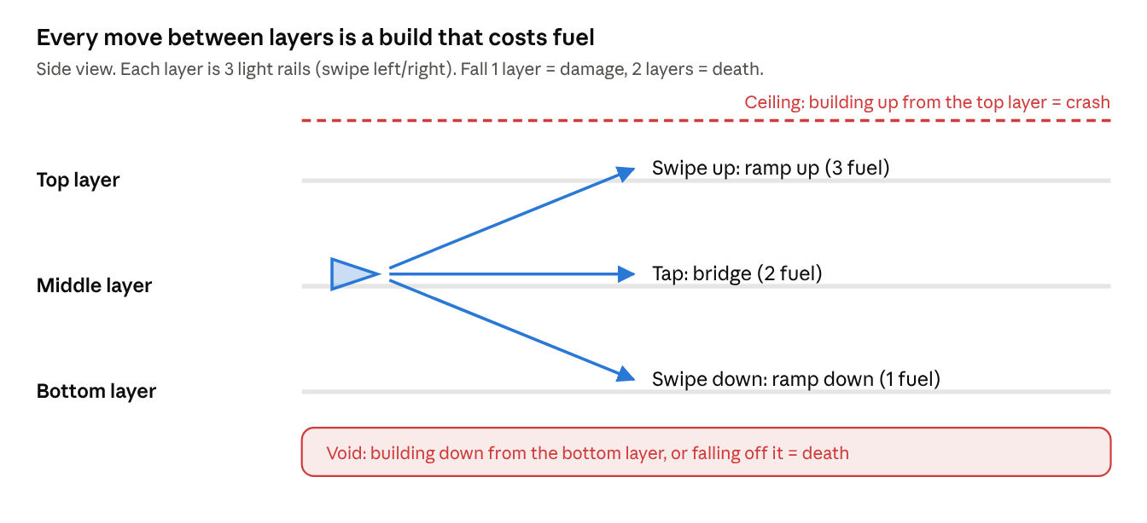
layers and build moves · side view
The ship can only change layers by building; the ceiling and the void are the hard edges. Fuel costs shown are starting values.

Controls and movement
Five inputs, all swipes or a tap anywhere on screen: left and right move, up, tap and down build.
Input | Action | Fuel
Swipe left | Move one lane left | Free
Swipe right | Move one lane right | Free
Swipe up | Build a ramp up one layer on the next tile | Highest
Tap | Build a bridge straight ahead on the next tile | Medium
Swipe down | Build a ramp down one layer on the next tile | Lowest
Rules
- 9 positions: 3 lanes x 3 layers (three light rails at each of the bottom, middle and top heights).
- The ship moves forward automatically; speed rises over a run.
- There is no free way up or down: changing layers always means building (or falling).
- A build needs fuel. With no fuel, inputs that build do nothing (red flash + "empty" sound).
- Tap versus swipe: a touch counts as a tap only if it barely moves.

Building and the fuel economy
Every build fills the next standard tile in your lane, whether or not there is a gap there, and costs fuel.
Tile rules
- Track is made of fixed-length tiles. A build always snaps to the next tile, not the next empty one.
- You can build anywhere: ramp up early to set up a route, or by mistake into something above.
- Building into an occupied tile (an obstacle or the ceiling) counts as a crash.
- A ghost outline shows where the next build will land.
Fuel
Piece | Cost (starting values, tune in playtests)
Ramp up | 3
Bridge | 2
Ramp down | 1
Starting fuel per run | 10
Max fuel (base) | 20, raised by upgrades
- Fuel/materials are collected along routes, often on riskier paths.
- The core tension: take the safe route that needs no building, or spend fuel to reach better rewards.

Falling, damage and death
The edges kill: a ceiling above the top layer and a void below the bottom one, with falls between layers as the soft fail.
Situation | Result | Shield?
Miss a build, fall 1 layer | Damage | Blocks it
Fall 2 layers | Death | No
Swipe up on the top layer (ceiling pinch) | Crash, death | Blocks it
Swipe down on the bottom layer (build into the void) | Death | No
Fall off the bottom layer | Death | No
Hit an obstacle | Death | Blocks it
- Ship HP: 3 (starting value).
- Repair power-up restores full HP; keep it rare and on risky routes.
- What is on the layer below is hard or impossible to see, so falling is a real gamble.
- Make the ceiling clearly visible on the top layer (glow or warning stripes) and introduce it safely in early levels.

Collectibles, power-ups and gem trails
Each collectible has one job, and gem trails double as the game's tutorial by leading players into building.
Collectible | Job
Gems | Currency; richest trails on the top layer
Fuel/materials | Pays for building
Shield | Blocks one fall, ceiling pinch or crash
Repair | Full heal (rare)
Instant build | Free building for a few seconds
Overload cell | Speed boost that breaks through obstacles and jumps gaps; must end on solid track or give a short grace period
Magnet | Pulls in fuel and gems
Gem trails
- Trails dip between layers and cross empty space, so finishing a trail means building.
- A trail into empty air teaches "build here" without a tutorial.
- Trails that go down and back up cost two builds: a greed decision.
- Lower layers get short trails; the top layer gets the richest ones.

Levels and difficulty
Levels 1–4 teach building with missing track only; from level 5, obstacles force route changes. Each level ends at a wall that carries the ship up to start the next.
Phase | What appears | What the player learns
Level 1 | Gaps on one layer, plenty of fuel | Tap to bridge
Level 2 | Ramps between layers, gem trails | Swipe up and down to build
Level 3 | Ceiling and void introduced near a shield | The edges kill
Level 4 | Tighter fuel, longer gaps | Fuel management
Level 5+ | Obstacles on paths (CubeField cube walls, Neo SlipStream ring segments) | Plan alternate routes
Level transition: the wall
- A perpendicular wall ends each level; the ship is guided up it.
- Checkpoint: show stats, offer an upgrade pick, optional rewarded ad for a bonus.
- Next level starts on the middle layer.
Within a run
- Speed rises gradually.
- Gaps, layer changes and obstacles become more frequent.
- Fuel gets scarcer, so every build matters.

Adaptive difficulty (−2 to +2)
A hidden skill rating from −2 to +2 tunes each run: strong players get tighter fuel and faster tracks, struggling players get more breathing room so they don't rage-quit. It sits on top of normal level scaling.
How the rating moves
- Every player starts at 0. The level 1–3 tutorial runs at 0 or below.
- After each run, compare the result to the expected result for their rating and level (distance, levels cleared, fuel wasted, falls, damage taken).
- Move the rating by at most ±0.25 per run, then clamp to −2 … +2.
- Rage signal: dying in the first 15 seconds twice in a row, or quitting right after a death, moves it down an extra 0.25.
- Use a rolling average of the last 5 runs so one run doesn't swing it.
R_{new} = \text{clamp}\left(R + 0.25 \times P,\ -2,\ 2\right), \quad P \in [-1, 1]
P = how far the last runs beat (+) or missed (−) the expected result.
What each rating changes (starting values)
Rating | Label | Speed | Gaps and layer changes | Fuel pickups | Obstacles (level 5+) | Shield / repair drops | Ghost outline lead time | Gem payout
−2 | Relaxed | 0.80× | 0.70× | 1.40× | 0.70× | 1.40× | Longer | 0.80×
−1 | Easy | 0.90× | 0.85× | 1.20× | 0.85× | 1.20× | Slightly longer | 0.90×
0 | Standard | 1.00× | 1.00× | 1.00× | 1.00× | 1.00× | Normal | 1.00×
+1 | Hard | 1.10× | 1.15× | 0.85× | 1.15× | 0.85× | Slightly shorter | 1.15×
+2 | Expert | 1.20× | 1.30× | 0.70× | 1.30× | 0.70× | Shorter | 1.30×
Values between steps are interpolated.
Rules
- Apply changes at run start and at each level wall checkpoint, never mid-chunk.
- The chunk generator still checks every chunk is affordable: fuel provided before a chunk covers the fuel it needs at the current rating.
- Edge rules (ceiling, void, 2-layer falls) never change with difficulty; only pacing and resources do.
- Gem payout rises with difficulty, so playing badly on purpose never pays better.
- Keep the rating hidden; optionally show a vague "Heat" meter.

Progression, upgrades and monetization
Upgrades keep pace with rising difficulty, and monetization follows the lineup's stack: Unity Ads rewarded first, small IAPs, cross-promotion.
Upgrades (bought with gems)
Upgrade | Effect
Fuel tank | Higher max fuel
Build efficiency | Lower fuel cost per piece
Starting fuel | More fuel at run start
Power-up duration | Longer instant build, overload, magnet
Hull | +1 max HP (capped)
Scanner (later) | Brief preview of the layer below
Upgrade costs rise about 15–25% per level; gem income rises with distance and level.
Monetization
Placement | Type
Revive once per run | Rewarded ad
Double gems after a run | Rewarded ad
Bonus at the level wall | Rewarded ad
Emergency fuel when empty | Rewarded ad
Between runs | Interstitial, light frequency cap
Remove ads, gem packs, ship skins, track themes | IAP
"More games" button + occasional banner | Cross-promo
Keep it fun-first: no pay-to-win walls and no forced ad spam.

Technical notes for Claude Code
Build the world as a tile grid (3 lanes x 3 layers x N tiles) assembled from hand-made chunks; reuse CubeField 3D for visuals and shared systems.
First task for Claude Code: read the CubeField 3D repo (read-only, do not modify it) and write a short inventory of reusable systems, then propose what to copy, adapt or replace for this game.
Grid model
- Each tile cell holds one type: Empty, Track, RampUp, RampDown, Obstacle, Wall (level end), plus optional pickups (Gem, Fuel, Shield, Repair, InstantBuild, Overload, Magnet).
- Builds write a cell on the next tile in the ship's lane; collisions are checked per cell, not with physics.
- The ship's layer only changes by riding a ramp or falling.
Chunk format (example)
tile,lane,layer,cell,pickup
0,1,0,Track,
1,1,0,Empty,Fuel
2,1,0,Track,Gem
2,1,1,Track,Gem
- Chunks are data files (JSON or ScriptableObjects) with tags: difficulty tier, fuel needed, fuel provided.
- The generator only places a chunk if the run can afford it (fuel provided before it covers fuel needed).
Expected reuse from CubeField 3D
CubeField system (expected) | Use here
Grid rendering, neon shaders, synthwave sun | Copy
Cube walls | Obstacles for level 5+
Overdrive meter and effect | Overload cell
Score, gems, save data, UI | Copy; separate save key
Unity Ads and IAP setup | Copy with new IDs
Ships, skins and ring segments come from Neo SlipStream. The CubeField column is a guess; correct it after reading the repo.

Footage and marketing
The signature visual is track snapping into place just before the ship lands; build the footage plan around it.
Footage type | Use | Notes
Calm runs | Clippie, FacelessGenie, other partners | Steady camera, action centred, middle of frame readable for captions, no menus or deaths
Action runs | YouTube Shorts, TikTok, store video | Last-second builds, gem trails, falls survived, overload smashes
Short hooks
- "Building the road as I fly it."
- "No fuel left, one gap to go."
- "Missed the bridge, dropped a layer, still alive."
- Add a background-mode flag that hides the HUD for clean recordings.
- Partner sets are exclusive; never reuse them publicly.
- Record 1080x1920 at 60fps, clips 30 seconds minimum, game name watermarked.

MVP scope, milestones and open questions
The MVP proves one thing: is building with limited fuel fun at speed? Ship that, playtest it, then layer the rest on.
Milestones
- Tile grid, auto-moving ship, swipe left/right lanes, ground layer only.
- Tap to bridge, fuel cost, fuel pickups, falling into the void = death.
- Playtest on a large phone one-handed. Go / no-go on the core idea.
- Add layers, ramps up/down, 1-layer falls with damage, ceiling.
- Gem trails, shield, repair, magnet, instant build, overload cell.
- Hand-made chunks with fuel tags; levels 1–5 and the level wall.
- Upgrades, Unity Ads placements, IAP, cross-promo.
- Polish: snap animations, sounds, background-mode recording.
Open questions
- ☐ Confirm BeamRunner clears App Store, Google Play and USPTO checks
- ☐ Does the shield block obstacle crashes, or only falls and ceiling pinches?
- ☐ Exact fuel costs, starting fuel and HP after playtests
- ☐ Does Overload end with a grace period or always land on track?
- ☐ Scanner upgrade at launch or later?
- ☐ Shared gem wallet across games, or separate?

